Thomas Jubb

MMA League Table
Computer Science NEA

Contents
User Interface 2
Decomposition 3
Inputs, outputs and processes. 4
User Interface 5
Data structure 6
Methods of Access 7
Database design - ERD 8
Data Dictionary. 9
Validation 10
Algorithms 11

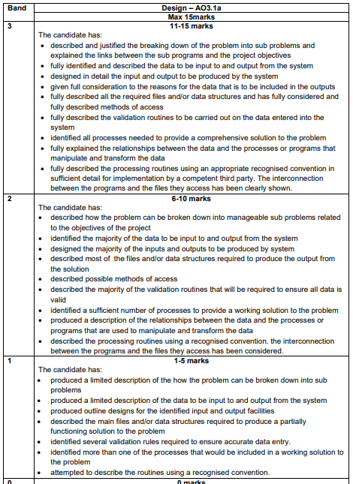
This is for your reference only and needs to be deleted when it is handed in as a final copy.

Please also delete any of my comments from the sections below, on final hand in

Flowchart
This diagram I made is a rough vision to help him home in on what I'm going to do for this project. shows how the user navigates through the system's processes for each page. When it has a box with two lines on either side, it means that the user is navigating to another page (Except on A, because that shows the program’s navigation in general). When the box is whole, it means that it’s a process.
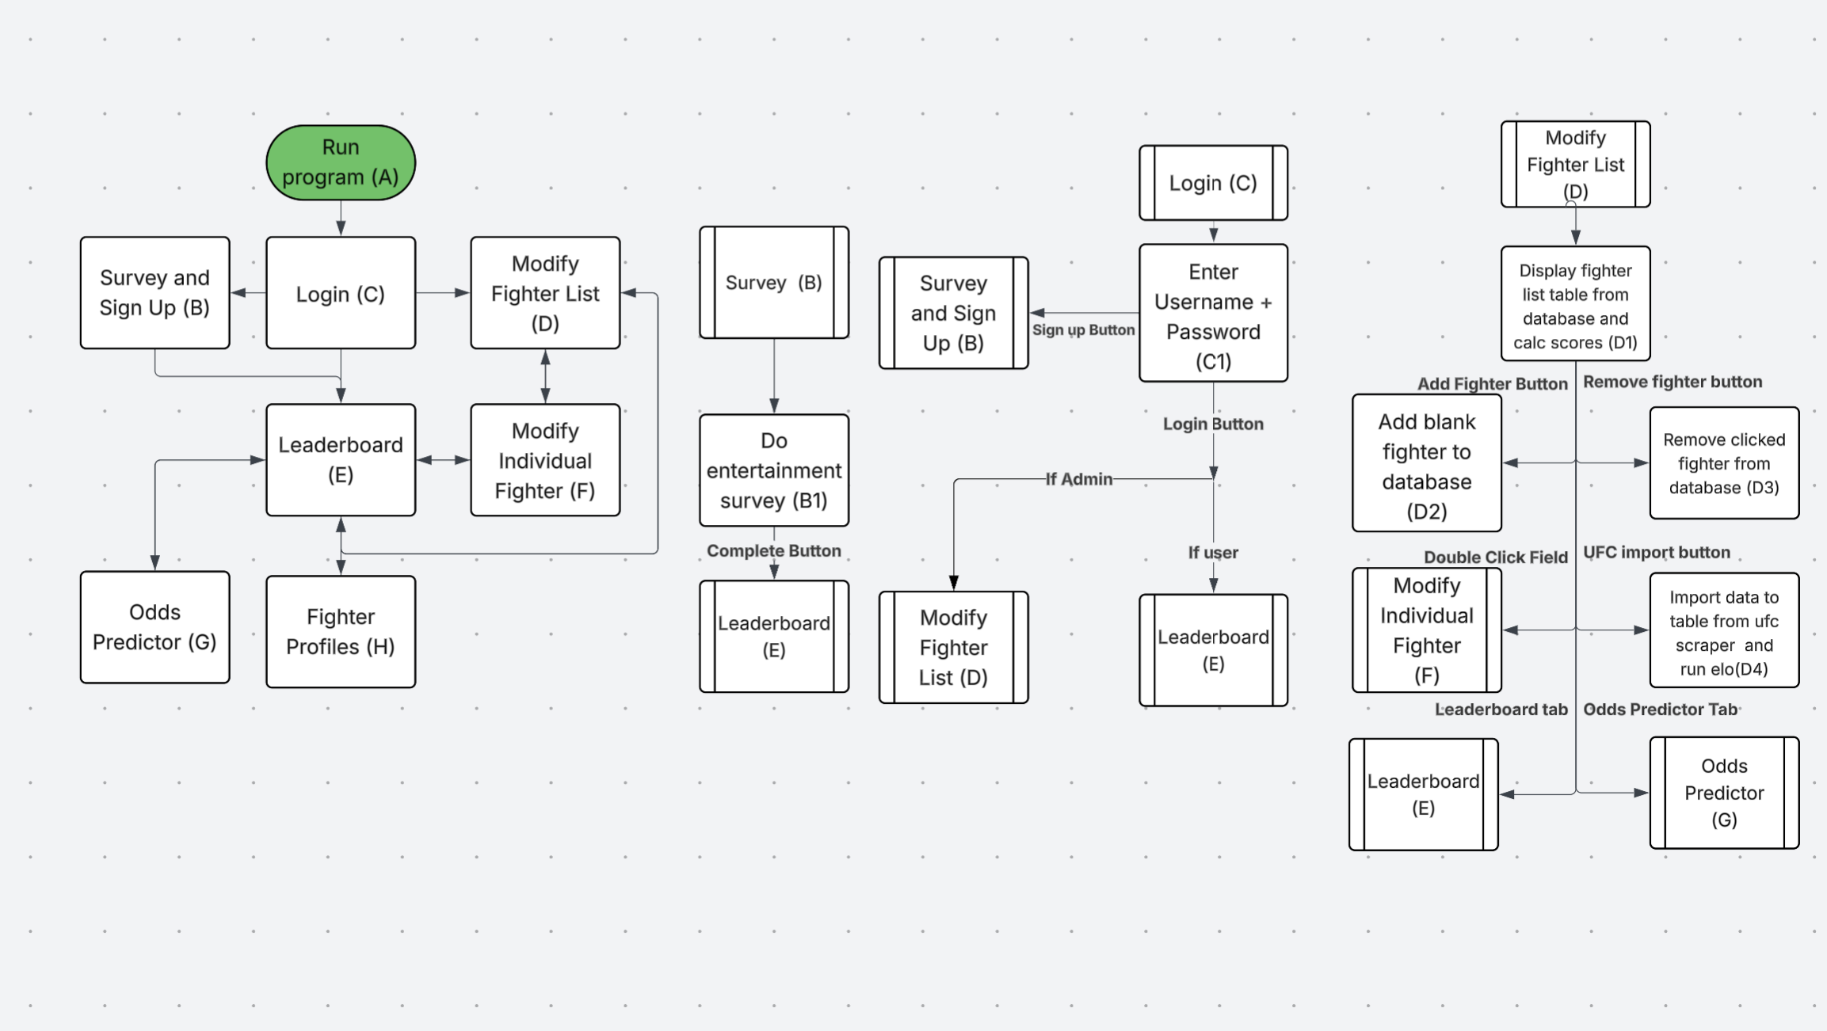
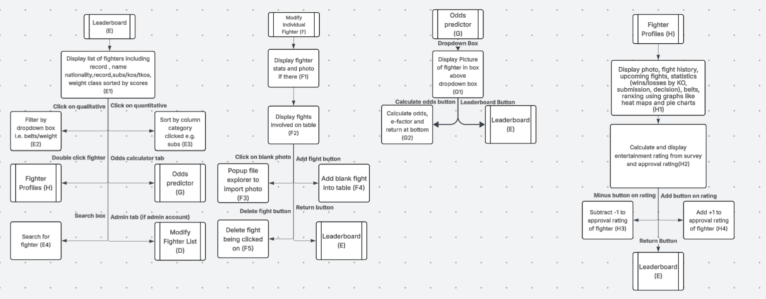
The letters and numbers signify a key. The letters signify the page you’re dealing with, and the numbers are to reference each process. For example, (F5) is a part of Modify Individual Fighter (F), where it pops up the file explorer to input a photo

Decomposition

Sub-Problem | Justification | Ref
Objective 1:The system will generate ELO scores for every fighter inputted by a system admin using the Glicko 2 model and output a ranked leaderboard (the ELO stuff will be done when the admin updates the table)
Do a search of all the fights in the database, ordered from oldest to newest | I can calculate the ELO changes chronologically | 1
Create a fake average fighter who has the average stats of every other fighter (the user shouldn’t see this average fighter) | This is so I can figure out the values a fighter has relative to all the other fighters. | 2
Start with the oldest fight, get fighter A’s ELO rating and put it into a variable | I can calculate fighter B’s ELO despite fighter A changing | 3
Convert Fighter A and B’s ELO and Rating Deviation to the Glicko-2 scale | Storing the fighter’s scores in a regular scale makes observation and testing easier and also works better with the odds calculation model. | 4
Update Rating Deviation based on inactivity | If a fighter is inactive, the system will be a little more sceptical about how they’re going to do when they come back. | 5
Calculate the impact of the fight | If a fighter has a more uncertain rating deviation, i.e. they are inconsistent, then the model will value winning against them less | 6
Calculate the expected score of the fight | Rating changes will be relative to how you’re expected to do, i.e. if you do better than expected, then you will get a better rating change. | 7
Calculate the variance of the fight | The variance affects the fight rating by figuring out how informative a fight is about the fighter’s skill from consistency, past opponents, etc | 8
Figure out the rating improvement from the fight | The rating improvement figures out how a fighter's rating should change relative to what was expected of them | 9
Figure out the volatility of ratings | Determines the stability of the rating changes | 10
Update rating deviation | New update to certainty | 11
Update main rating | New ELO ratings that reflect fighter’s skill after the fight | 12
Reconvert RD and score into normal scales from Glicko’s scale | Same reason as 2 | 13
Repeat in reverse | This is to handle the changes on the other side | 14
Repeat for next oldest fight | Moving onto the next fight | 15
Display table to User/Admin sorted by external ELO score | Both parties are going to expect that you’ll give them a leaderboard that is sorted by ranking | 16
The leaderboard will display the fighter's name, rank number, record, win/loss streak, weight class and methods of winning (number of subs/decisions/kos). (Whenever I refer to displaying the table, this is the general process.)
Connect to the database | This is to I can interact with the SQL database | 17
Execute a search query of the fighter list (or if we’re doing something else we do that table), excluding stuff that isn’t necessary for the user to see, such as photo data and ranking data, ordered by whatever order is needed | This brings up all the stuff we’re going to display | 18
Clear the table we’re inserting into | This is to get rid of whatever was there before; if we don’t, we may risk mixing old stuff and new stuff. | 19
Iterate through rows and insert each row into the SQL table | This is to display the table to the user properly | 20
The table will be sortable by all displayed factors, as well as weight class, nationality, and the belts they’ve held
On the user clicking the top bit of their table, sort them by the factor they clicked if it’s quantitative. If they click it again, sort it the other way round | Sorting the info by a factor allows the users to see the table by who has the most of whatever factor they want to look at | 21
On the user clicking a qualitative top bit of the table, do an SQL selection of all the possible qualitative parts of the table, put them all in a dropdown box and then do an SQL selection of all fighters who have that factor. | This allows the users to see all fighters with the qualitative factor they want to see. | 22
On the user and admin side, you will be able to search for a fighter's name using a Levenshtein (edit based) distance system.
Find all fighter names after the user presses the search button (if it’s blank, deny search) | This brings up all the fighter names so the system can process the closest matches to the search term. The algorithm can deny the search if it's blank because nobody has a blank name. | 23
Take the first fighter’s name and create a 2d matrix list based on the fighter name and the search term | This is so we can go through each variation of the search, so that we can see what cost to the edit amount each variation has | 24
Go cell to cell, finding the least amount of edits needed for each part of the string | This makes it so that the further we go, the closer to the minimum the edits needed will be | 25
Take the minimum amount of edits (bottom right if you visualise the list like a matrix) and put that minimum edit distance into a list with the fighter’s ID | We are saving the minimum edit distance for later, so we can order it by the smallest edit distance first for the user. | 26
Repeat these steps for each fighter | This gives us all the Levenshtein distances to the search term | 27
Quicksort the minimum edit distance list in ascending order | This is because we’re going to display the list by the smallest edit distance first to the user | 28
Redisplay the fighter list to the user/admin, ordered by the minimum edit distance list | The system will output a list ordered by how close to the search term each fighter's name is, which is what the user wants | 29
5. On the user and admin side, you will be able to click on a fighter’s row and then see their profile come up
On double click, switch page to the fighter page | This is to show the user the page of the fighter. | 30
6. The fighter profile will feature a photo of the fighter, their past fight history, win streak, upcoming fights, statistics (wins/losses by KO, submission, decision) and belts
Find the picture of the fighter from the fighter variable and put it onto a widget | This is to show a photo of the fighter to put a face to the name of the fighters | 31
Find and display fights where the fighter we’re looking at has fought. | This is to show the user the fighter’s past opponents to contextualise the skill of a fighter they don’t know to other fighters. | 32
Calculate and display the fighter's win/loss streak | This shows the user what’s at stake if the fighter fights, i.e. they lose their win/loss streak | 33
Calculate total wins/losses/draws and their individual totals (i.e. total KO losses, total sub wins, etc.) and display in a table | This shows the user what to expect in a fighter's fight (i.e. to expect a submission from the fighter if they are a submission artist) | 34
Calculate the percentage win rate and percentage finish rate for the user | Same reason as the previous sub-problem (to show what to expect) | 35
Find belts held by the fighter and display them to the user | You want to show what belts someone has to see what's on the line when they fight. | 36
The fighter profile will also show a pie chart that shows wins to losses and then decomposes to subs/kos/decisions to help users visualise the info.
Find fight data and calculate total wins and methods of winning, losses and methods of losing | This is so we can put all the data inside the pie chart. | 37
Create a pie chart for the widget | Like the objective says, this is to allow the user to visualise all the info | 38
The fighter profile will also show a table that lists the wins that the fighter has against the people who are currently ranked in the top 10 of their division.
Calculate the 10th fighter of the fighter we’re looking at’s division’s score. | This is so we can look at all the ones who have a score equal to or greater than the 10th best fighter (the top 10) | 39
Find all fighters with ELO equal to or greater than the ELO of the 10th best fighter in the division, and put that result into a table | This is to show the user the more “notable” fights a fighter has had. Also, the user is way more likely to recognise the higher-ranked fighters. | 40
The system must take an input of two fighters and give the odds of either of them winning by putting the ELO score they have through the Bradley-Terry model.
Display all fighters (only ones in the weight of the other fighter if another fighter has been selected in the other box) in a drop-down box, sorted alphabetically | This makes it all compact for the user, but ordered so they don’t have to search too much | 41
When the user clicks calculate, calculate the odds of the fight using a logarithmic Bradley-Terry model | The reason why I used a logarithmic version is that a logarithmic adaptation of the Bradley-Terry model works way with the Glicko ratings we have. | 42
Display odds in a percentage, depending on who has the dominant rating | This is to display the odds calculation of the fighters to give users an idea of how individual fights will go | 43
Upon first use, the system must prompt the user to make a profile so they can answer a short survey about what they find entertaining about an MMA fight. Using this, the system will be able to show how entertaining a fight is going to be to you based on what you like from the survey.
When the user signs up, the system checks for a duplicate username and then will hash and salt their password and store it along with their username | This is to keep everything as secure as possible. I know the information being stored isn’t too sensitive, but people reuse their passwords, so passwords are sensitive information. | 44
The user will be able to log in again using their username and password. | This is so users can access their approvals and entertainment data again. | 45
When the user logs in, if everything is valid, the session will be connected to the user by a variable. | This is so the session can figure out what user is using it. | 46
If the user has an admin account, the session will be an “admin” session (declared by a variable), meaning that they will be able to access admin tabs. | This is so the admin can use their admin tools during their session | 47
When the user clicks submit on the survey (what they like out of 5 stars), put the 5-star score into another scale and store it in the user’s records | This is so we can use bad opinions as a divider and good opinions as a multiplier | 48
When the user uses the odds calculation, match each answer the user put on the survey to an attribute of the fighter. | This is so we can figure out which attributes the user likes, and what attributes the user doesn’t like and how the fighter scales up to it | 49
Go through each of the attributes relative to the average fighter to figure out what they do more than average (aforementioned), and both fighters are being calculated (this part happens when the user calculates the odds) and Give both fighters a percentage score based on what they do more or less on average, according to the user’s opinion | This is so we can show the user how entertaining the fights will be, which gives them a better idea of how good the fight will be and if it's worth anticipating. | 50
Admins will be able to manually input fighters and fights
When the admin selects Add Fighter create a blank fighter, the admin can go onto their page and edit | This is so the admins can add more fighters manually to the database | 51
On the individual fighter editing page, when the admin clicks add fight adds a blank fight to the fighter list that you can edit with dropdown boxes and such | This is to make the admin's life easier, so they don’t have to manually put in names/ids | 52
Admins will also have the option to use a UFC scraper.
Insert every fight since a given date and add it to the database | This is so we can link all the fights as a baseline, so you don’t have any fights without known fighters | 53
Link every fight to a fighter and build the fighter’s profile. | This is so that each fighter has their profile for people to use the system to see UFC stats | 54
Run Glicko Scores and Averages | This is so we can use all the other system stuff with our UFC scraped stats | 55
The system will validate inputs by rejecting duplicate data and incorrectly formatted records
Find duplicates in the data, tell the user and make them delete it before all the updates are made | This is so we can make sure all the statistics we do are accurate and that data entry and deletion are way less complicated | 56
Find incorrectly formatted data, and show the user what’s wrong and make them delete it before the updates are made | This is so that the calculations we do on the data work | 57
Users will be able to vote on fighters and give them a percentage approval rating
When the plus button is clicked (if not already), store the user's vote in the database | This is to show the user’s approval of the fighter | 58
When the minus button is clicked (if not already), store the user’s vote in the database | This is to show the user’s disapproval of the fighter | 59
When the user brings up the fighter’s page, view the approval rating as a percentage positive if mostly positive or a percentage negative if mostly negative | This is to show other users’ approval of the fighter | 60
The system will give each fighter a score according to the fighter’s info to determine how entertaining the user will find the fighter.
Find out how user entertainment survey responses compare to average fighter attributes | This is to show how entertaining you find the average fighter, so you can work out how relatively entertaining the fighter is | 61
Find out how user entertainment survey responses compare to the fighter we’re looking at’s attributes. | This is to figure out how baseline entertaining the fighter is | 62
Give a score of how entertaining the fighter is relative to the average fighter | This is to show the user whether they are more likely to like the fighter they are looking at or not. | 63
When the admin makes an update on a table, the program will validate all of the data, check for inconsistencies, check for data redundancies, and check for statistical anomalies
Check that all data formats are correct | This is so that all the data manipulation we do isn’t messed up by issues | 64
Check that the data isn’t too long | This is because data that is too long will have other issues and will be difficult to process, just to be pointless | 65
Check all fights for 2 fights and events that have happened with the same fighters on the same day, and bring it up with the user to help them delete it | This is to stop duplicate fights, which mess up averages and ELOs | 66
Check for impossible statistics (i.e. a record of 400-0) | This is to get the impossible stats that will really mess up the database and the averages, and everything | 67
Check for duplicate fighters and don’t allow duplicate usernames | This is to remove the problems that will happen if there is data duplication | 68

Inputs, outputs and processes.

For each of your sub problems, you need to identify the inputs, outputs and processes.
Sub Problem Ref | Input | Process | Output
Do a search of all the fights in the database, ordered from oldest to newest (1) | Fighter, events, fights data  Admin clicks the Submit button | SQL search of all fights, ordered by oldest to newest | The fight table, ordered from oldest to newest.
Create a fake average fighter who has the average stats of every other fighter (the user shouldn’t see this average fighter) (2) | Fighter and fight data | Calculate the average of each quantitative value and insert the average fighter into the database | Average fighter to use for relative values
Start with the oldest fight, get fighter A’s ELO rating and put it into a variable (3) | Elo of fighter A | Store ELO into a variable | ELO in variable
Convert Fighter A and B’s ELO and Rating Deviation to the Glicko-2 scale (4) | Fighter A and B ELO rating  Fighter A and B rating deviation | 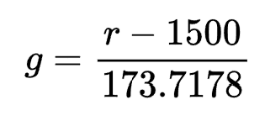  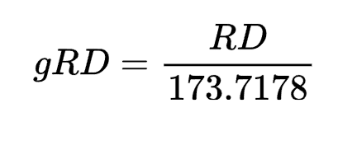  g = Internal Glicko rating  r = External ELO rating  gRD = Glicko rating deviation  RD = external rating deviation | Internal Glicko rating  Glicko Rating Deviation
Update Rating Deviation based on inactivity (5) | Old rating deviation  Volatility  Months since last fight | 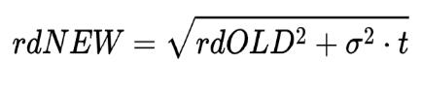  rdNEW New Rating deviation  rdOLD = Old rating deviation  sigma = volatility (updated later, but we use the old fighter volatility)  t = months since last fight | New rating deviation
 |  | 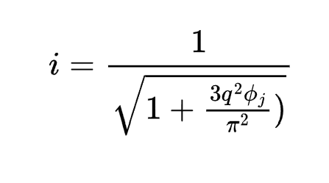
Page Redirects (General) | User/Admin does something which causes the page to redirect | Page variable is set to the current page; all the other pages not being used are hidden. | User/Admin is redirected to another page
Do the Entertainment Survey (B1) | User answers a questionnaire of ratings 1-10 about their opinion of submissions, knockouts, decisions, how valuable being unbeaten is to them and how valuable a streak is to them. When done, click the complete button. | Run an SQL query to add the answers to the questions to a table in reference to the user’s ID, which is figured out by the session userID made when the user signed up. | Redirect to the Leaderboard (E)
Enter Username and password on login (C1) | User/Admin enters their username and password into the box and clicks the login or sign-up button. | If the login was pressed, run an SQL query to figure out if the user exists and is an admin or not. If so, set isAdmin to True and vice versa. Set the session userID to the user ID found from the search. If the sign-up was pressed, check if the username and password are valid, and then do an SQL query to add the user to the table as a regular user. Set the isAdmin variable to False, the session userID to the user’s new ID. | If there is no match, show an error.  If the user is an admin, redirect to Modify Fighter List (D).  If the user is a regular user, redirect to Leaderboard (E)  If the user clicks the sign-up button, then redirect to Survey(B)
Display the  fighter list table from the database and calculate scores (D1) | On redirect to Modify Fighter List (D) | Do an SQL query to set all fighters to a default ELO of 1500 and then get all the fights in the database in chronological order. Go fight by fight and compute the way ELO scores are affected for each fighter involved from each fight using the Glicko-2 Algorithm. Turn each fighter’s name into lowercase and then a list of ASCII numbers, add together the numbers and put this value in a table with ID for searching. Do an SQL query to get the fighter table. | Output the fighter table onto the table on the page
Add Blank Fighter to the database (D2) | Admin clicks the "Add fighter” button | Run an SQL query to insert a new blank fighter into the fighter’s database using generic values | Output the new fighter addition onto the table
Remove the fighter from the database (D3) | Admin clicks a fighter’s field and then clicks the “Remove Fighter” button. | Run an SQL query to remove the fighter that is being clicked from the database, and all the fights involving them | Output the new table without the deleted fighter
Import UFC data to a table from the scraper and run ELO (D4) | Admin clicks an “Import from UFC” button and then a further “Are you sure?” pop-up | UFC scraper returns all active fighters and all fights since 2020. All the fighter and fight data is put into the tables, normalised and then all the fighters who aren’t recorded fighting are redacted. The system will check which fighters had belts and assign them their values. It will be the same thing as (D1), where a default ELO is assigned, the fights are put into chronological order, and the system calculates how the fighters involved in each fight have their ELO changed. | The table is updated with UFC fighters.
Display list of fighters including record, name, nationality, record, subs/kos/tkos, weight class, sorted by scores (E1) | User Navigates to Leaderboard (E) | The system runs an SQL query to return the fighter list sorted by highest ELO first, where it shows their record, name, nationality, methods of victory, and weight class. | The table is displayed through the table UI on the Leaderboard
Filter by dropdown box, i.e. belts/weight (E2) | User selects a belt or weight class from the box | The system runs an SQL query to return the fighter list from E1, but with only the ones that held whatever belt they specified or whatever one from a specific weight class | The table updates to the new filtered one.
Sort by column category clicked, e.g. subs (E3) | User clicks/double clicks the top part of a column | The system runs an SQL query on the current list criteria and instead sorts it descending by the category the user clicked, e.g. submissions. If the category gets double-clicked, then it will be sorted in ascending order | The table updates to the new sorted one.
Search for fighter (E4) | User inputs a name and then clicks the search button | The system turns the term lowercase and into an array of ASCII numbers, which it sums. It then takes the ASCII total table of the other fighters and makes a 2d array which has the differences of every single fighter’s total. The system then sorts it by the smallest difference first. The SQL table then gets output in the order of the IDs
Display fighter stats and photo if there (F1) | On redirect to (F) | Do an SQL query and find the photo of the fighter, and find all the stats of the fighter | Display the photo on the photo slot in the individual fighter page, and put the stats in editable boxes
Display fights involved on the table (F2) | On redirect to (F) | Do an SQL query of all the fights that have the fighter whose page has been opened | Display the result of the query in the table
Popup file explorer to import photo (F3) | Admin double-clicks the photo slot and selects a photo | An SQL query inserts the image and the fighter ID it comes from into a table | Display the image in the image slot
Add blank fight into the table (F4) | Admin clicks the “Add fight” button | An SQL query inserts a blank fight with the fighter whose page is open, being one of the fighters | Display the new blank fight on the fighter profile table
Delete fight being clicked on (F5) | Admin clicks a fight and the “Delete fight” button | An SQL query deletes the fight being clicked on | Display the new table without the fight that got deleted
Calculate odds, e-factor and return at the bottom (G1) | User selects two fighters from two drop-down boxes and then presses a “run odds” button | An SQL query retrieves both fighters’ data, such as their ELO and the records of the opponents they have won against. It then determines how much data it has. If it has enough, it runs the odds using the Glicko-2 model, and if it doesn’t have enough, it uses the Bradley-Terry model. The system also checks the fighter’s methods of victory and win streak, and matches them up to figure out how entertaining the person will find the fight | The program returns the percentage odds and the predicted entertainment factor of the fight
Display photo, fight history, upcoming fights, statistics (wins/losses by KO, submission, decision), belts, ranking using graphs like heat maps and pie charts (H1) | On redirect to (H) | Run an SQL query to retrieve the photo, belts, and ranking. Create an array of 3 items: wins, losses, KOs, subs, and decisions. Tally them up using an SQL query of all the fights involving the fighter. Generate a pie chart between sub/ko/dec, and then generate a pie chart based on wins/losses | Displays the fighter profile and info in charts and text format, and also shows the belts the fighter has
Calculate and display the entertainment rating from the survey and approval rating(H2) | After (H1) | Run an SQL query to get the opinion survey up and scale each quality to how much a fighter does that, i.e. if you value subs and the fighter does subs, the score goes up from the original score. | Display the entertainment rating as an amount from 1 to 10
Subtract -1 from the approval rating of the fighter (H3) | When the user clicks a -1 button on the approval rating of a fighter | Run an SQL query to add one to the disapproval votes of the fighter on a table, and redisplay the new percentage | Display the approval rating from the fighter profile
Add +1 to the approval rating of the fighter (H4) | When the user clicks a +1 button on the approval rating of a fighter | Run an SQL query to add one to the approval votes of the fighter on a table, and redisplay the new percentage | Display the approval rating from the fighter profile

User Interface
Don’t be deceived by the title, you need to design every form you will be creating, including error messages. These need to be fully annotated, you will be showing these to your peers, they should have enough detail to be able to pick up your idea and program it. You should link these with the objectives in the design or your decomposition tasks.
General exceptions or other code errors:
As a baseline catch for errors in my prototype I am using Tkinter so it will look something like this when an error happens:
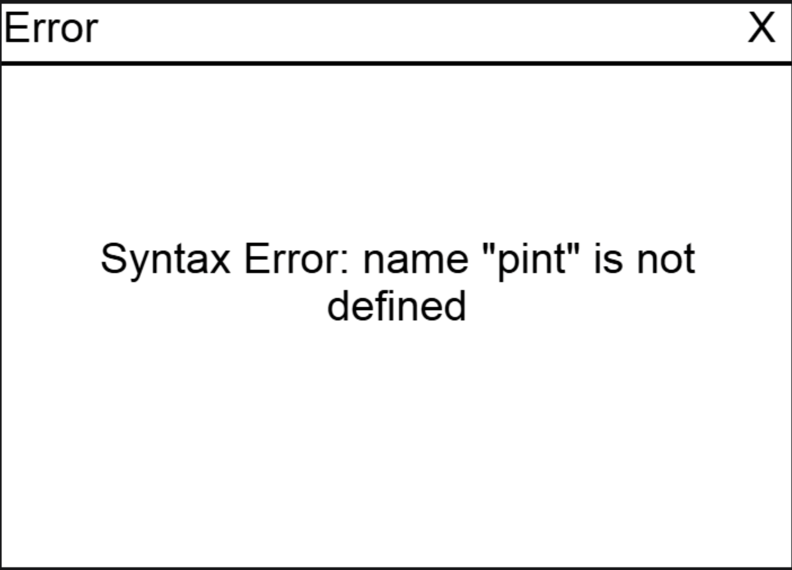

Login
*Annotations in green
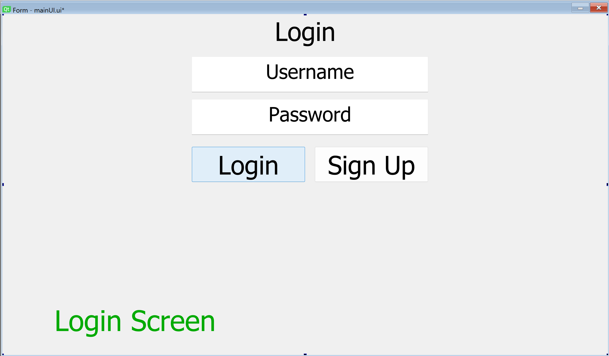

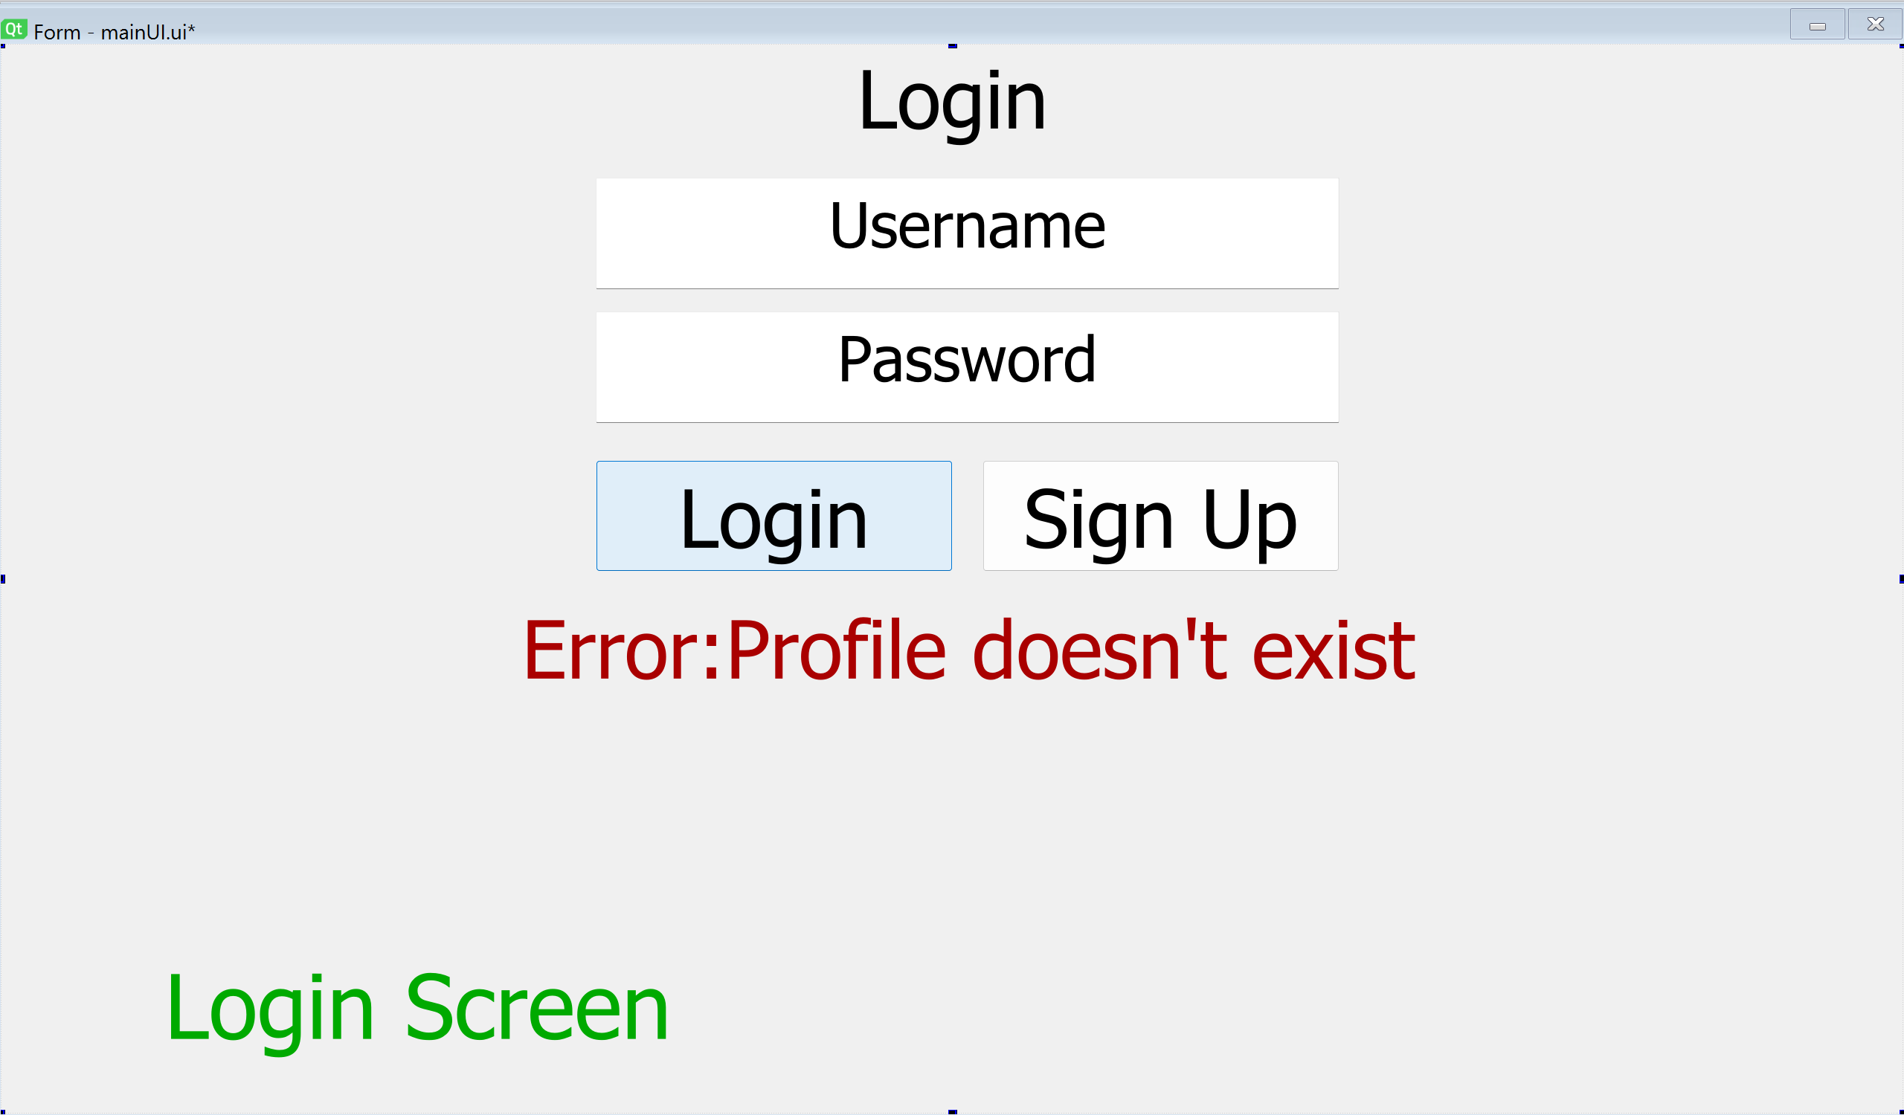
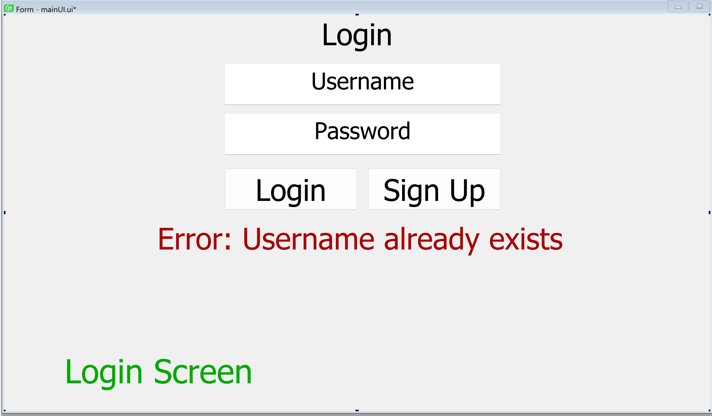
Survey
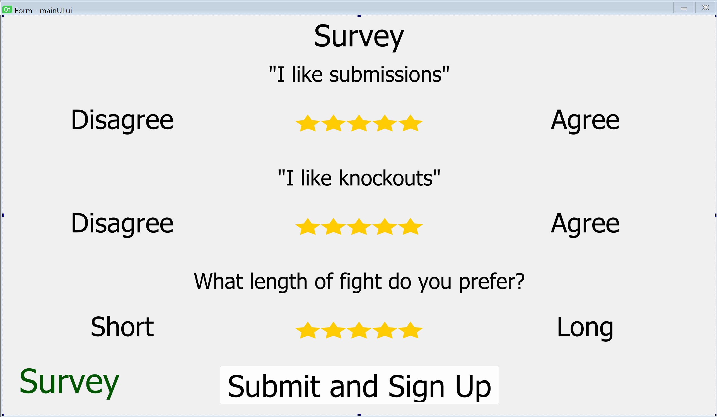
Odds Calculator

Fighters are selected from a dropdown box
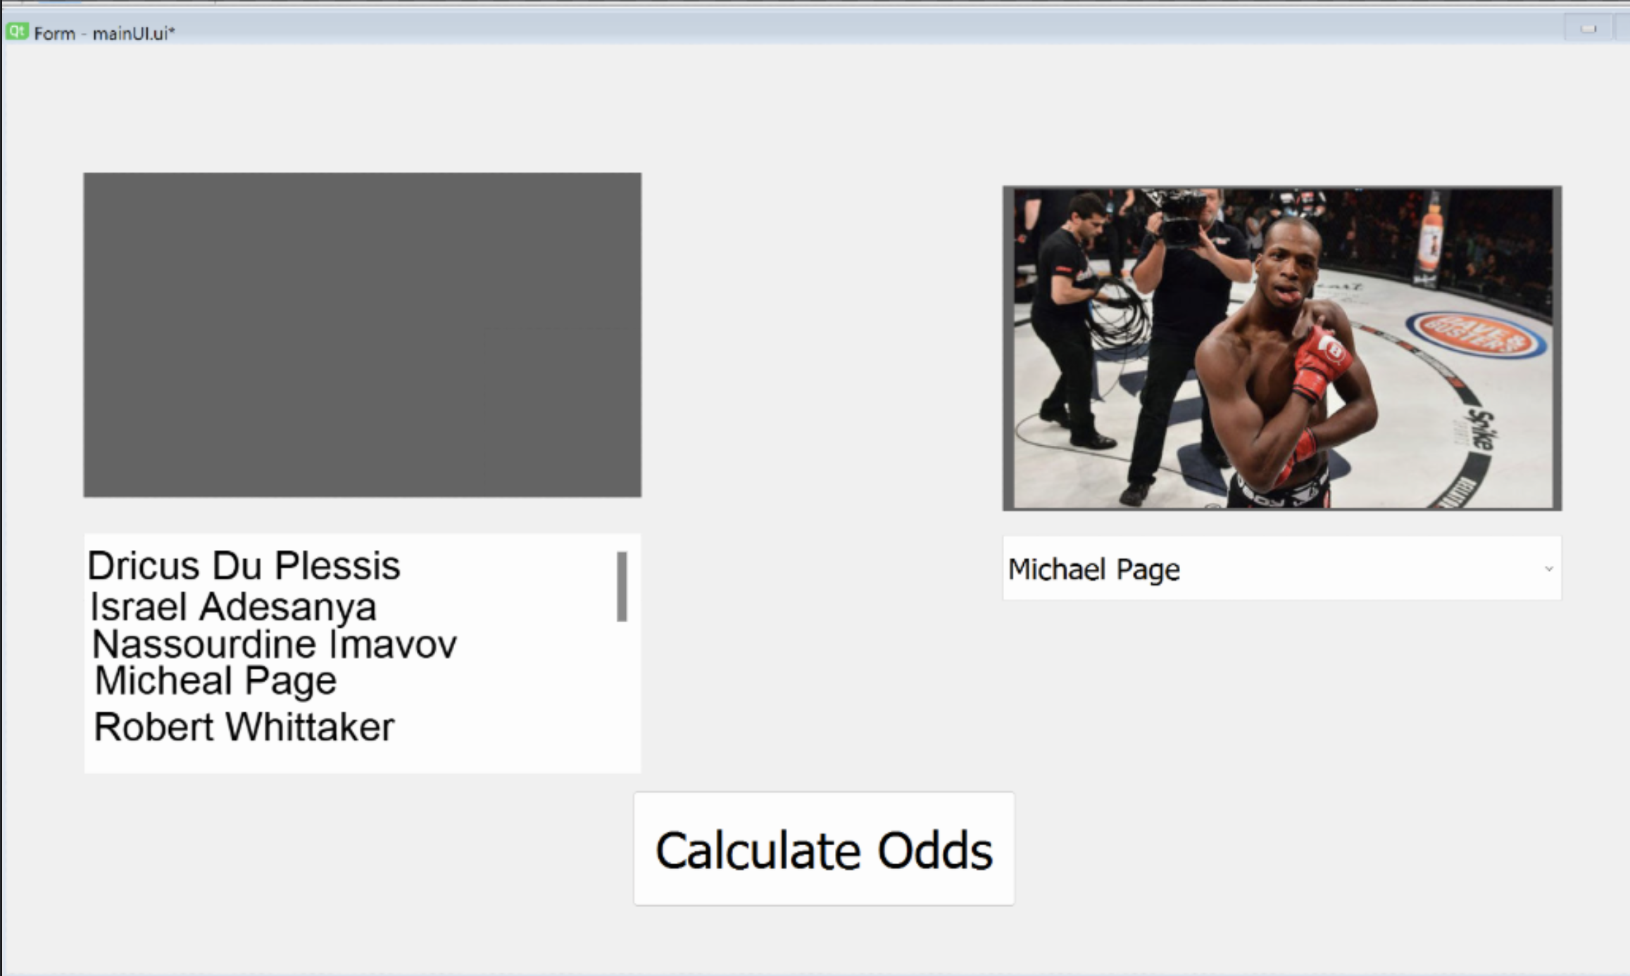

When you select a fighter from the dropdown boxes, their picture will appear
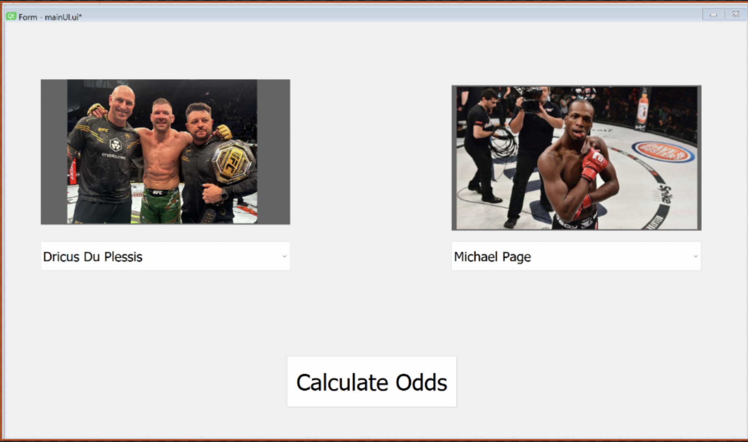
(When clicking Calculate odds button)
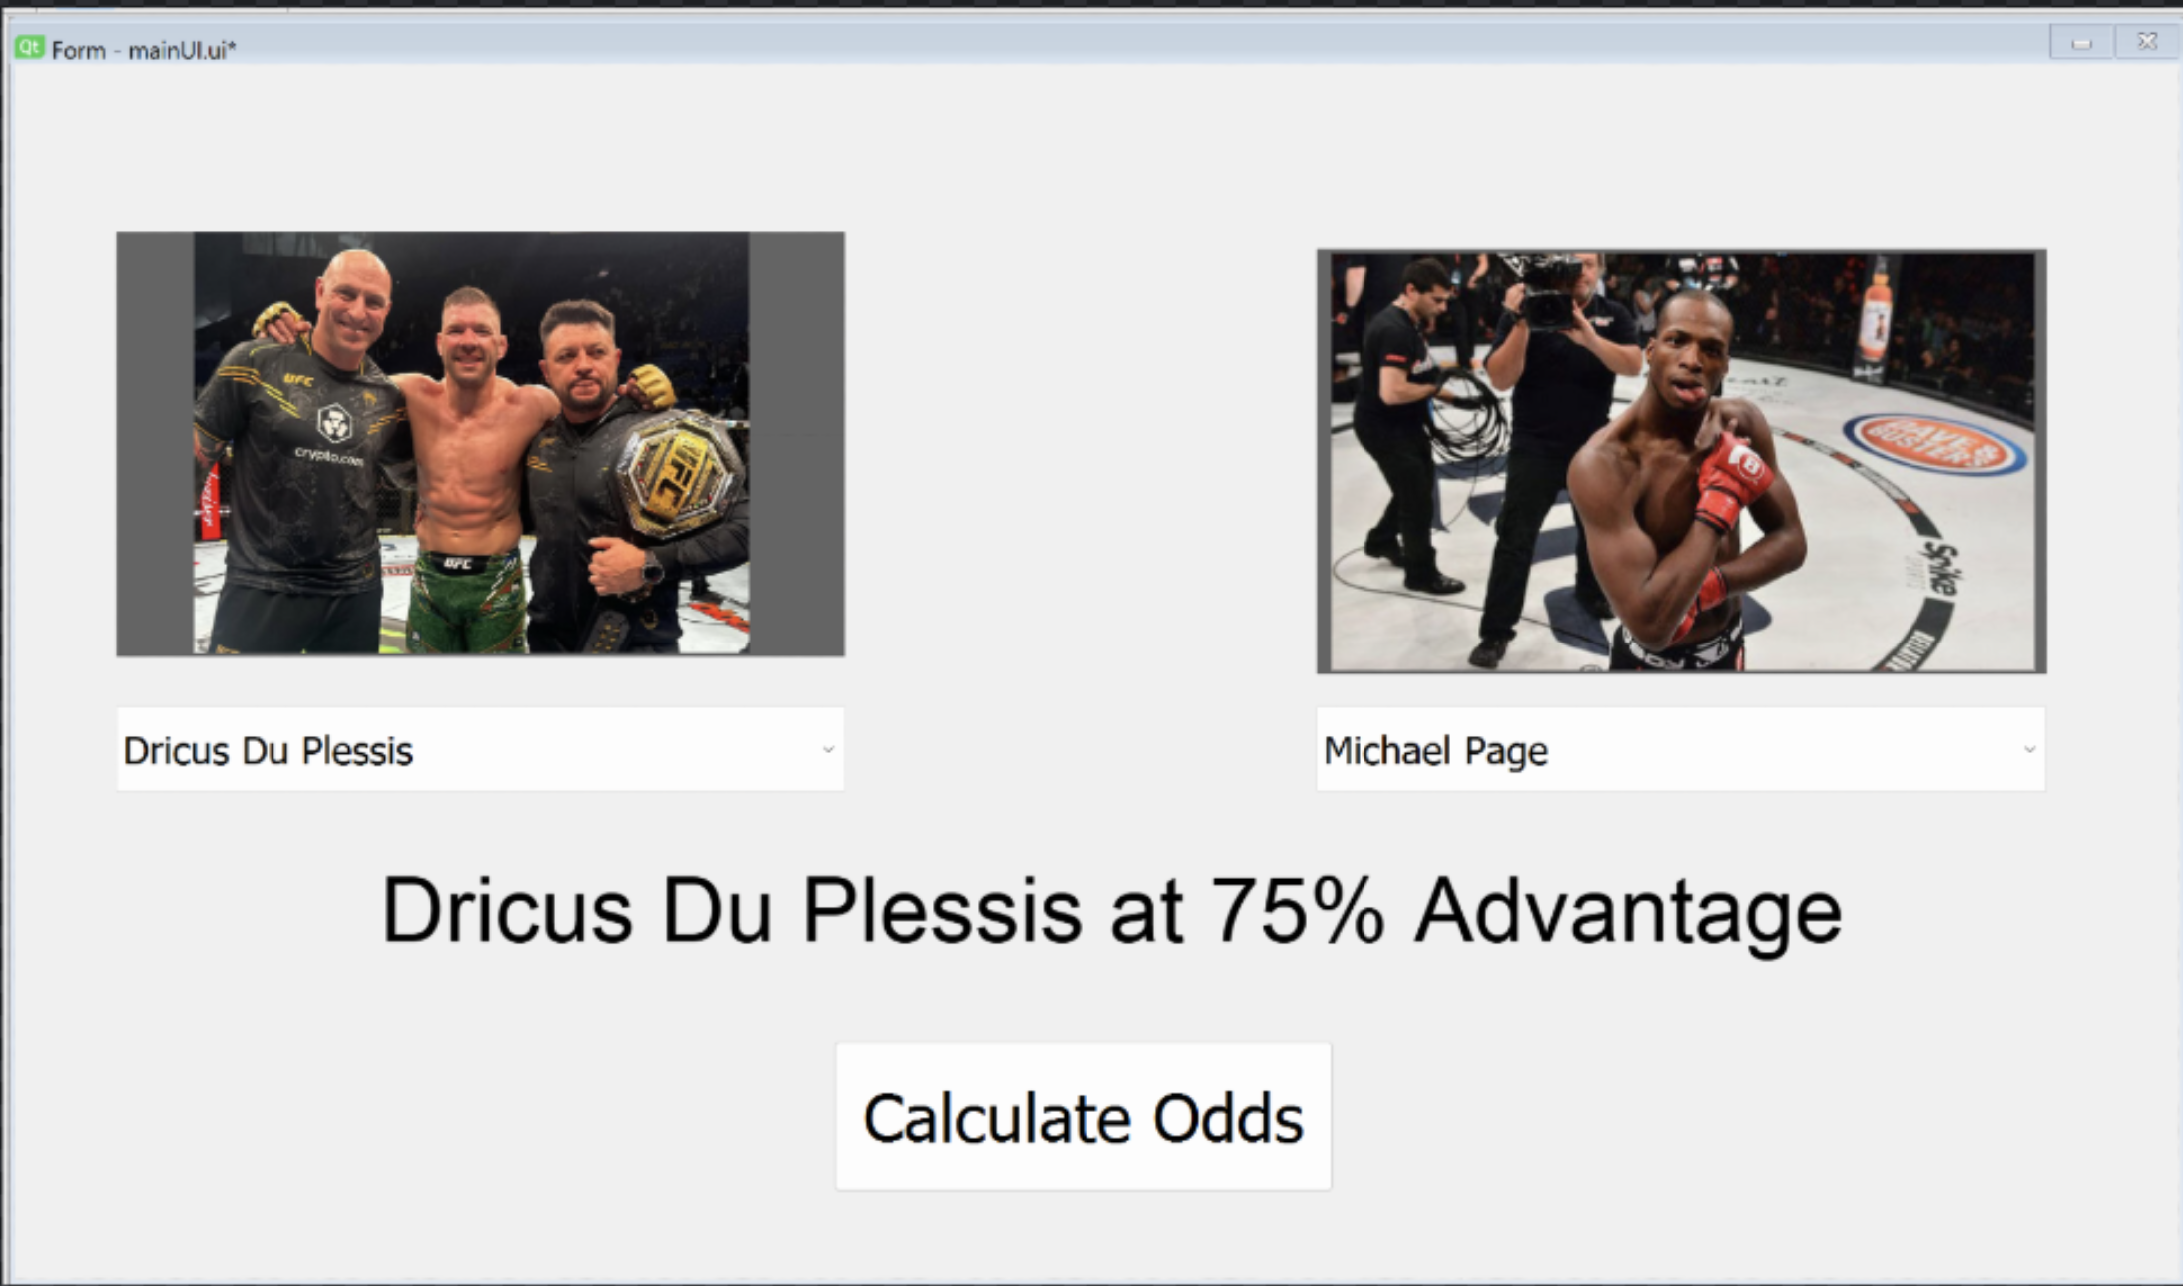

(When clicking the button when one or both fighters are missing)
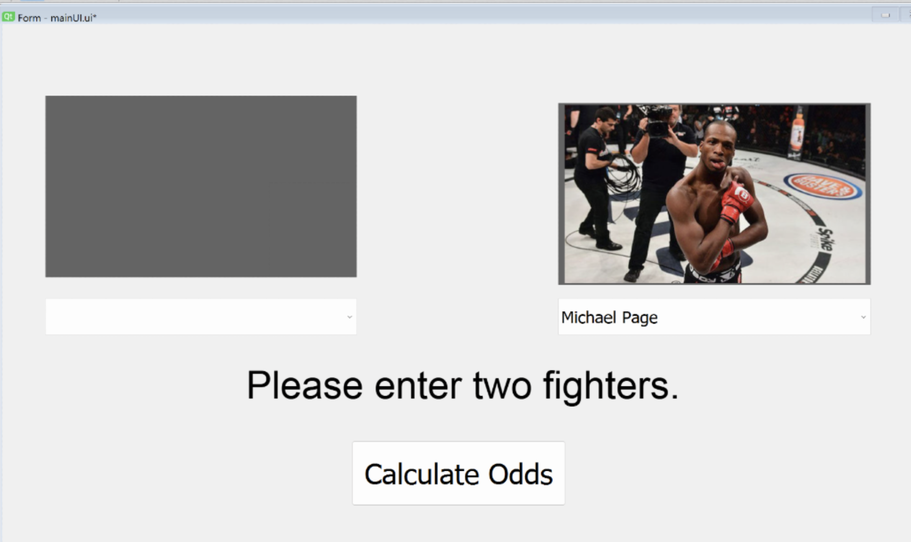

Data structure
Describe why you will be storing the data in a SQL database, what features it has that suit your project etc.

Methods of Access
You need to identify the methods of access for each of your purposes. These can be:
- Direct – searching directly using a primary key, highly efficient as it will only produce a single result, ie a customer number
- Indirect – searching using a variable that can be duplicated in a file, ie a customer name.

Database design - ERD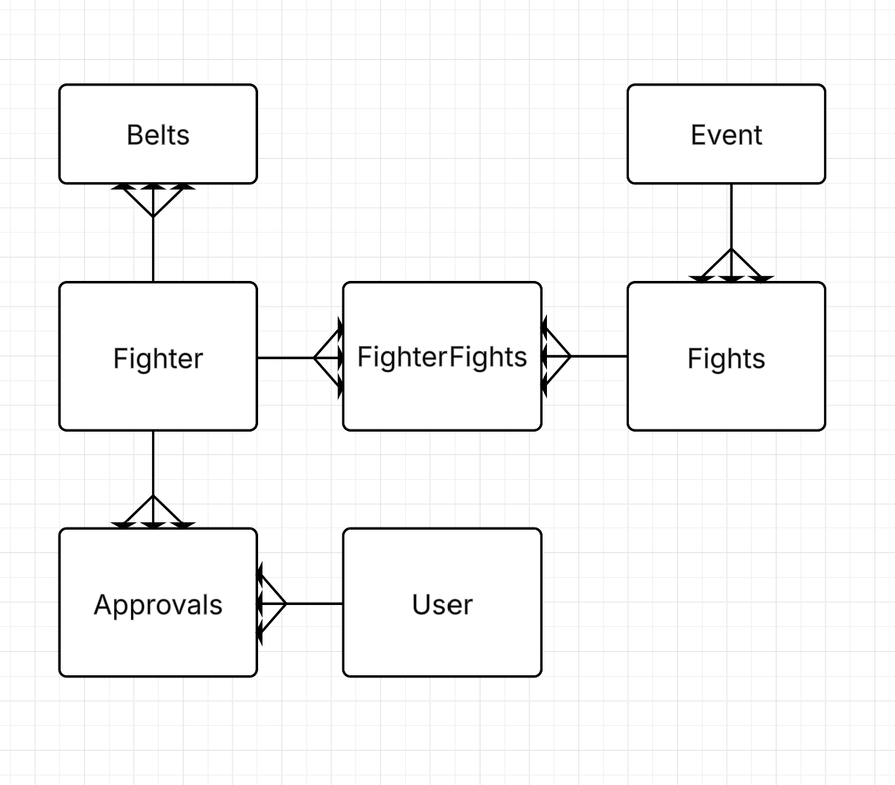

Justification of ERD
These are the main entities that are interacted with in the system. This entity relationship diagram shows how each of them interacts with the other. The admin enters an event into the system. Every event has many fights. Many fighters have many fights, so I have an intermediate Fighter Fights table. A belt can only be held by one fighter, and a fighter can have multiple belts
The way the User interacts with the fighter’s data is through their approval ratings. A user will vote a fighter up or down. One user has many Approval ratings. Many approval ratings are linked to one fighter.

Data Dictionary.

EVERY table you have identified in your ERD MUST have its own Data Dictionary!! Each one should have its own separate table.
Table Name
Field Name | Data Type | Description | Validation | Key

Validation

Probably the most important aspect of the project. This is looked at to judge the level of the project. You need to explain the different validation you will use. You should discuss each validation technique you will use from above and any try except statements or additional python validation you will include.

Algorithms

Each sub problem you have identified needs an algorithm. I don’t need to see any user interface algorithms, but I need to see everything else. Please make sure you use suitable pseudocode, it can’t look too ‘pythony’

